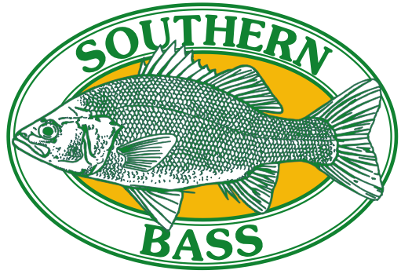

**Invite’s you to fish the**

**LAKE YARRUNGA BASS CATCH**

**25th - 27th FEBRUARY 2022**

**Entry Fee: $30.00 (senior) $15.00 (junior under 16 years)**

**Entry fee allows for honorary membership for duration of bass challenge 6.30pm Friday till 2.00pm Sunday**

**LIFE JACKETS MUST BE WORN BY ALL PARTICIPATING ANGLERS WHILST ON THE WATER**

**THIS WILL BE A SINGLE PERSON ENTRY EVENT NOT A TEAM EVENT**

**We like to thank our PREMIUM SPONSORS**

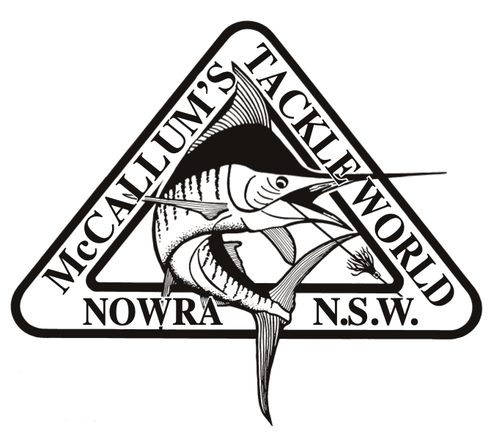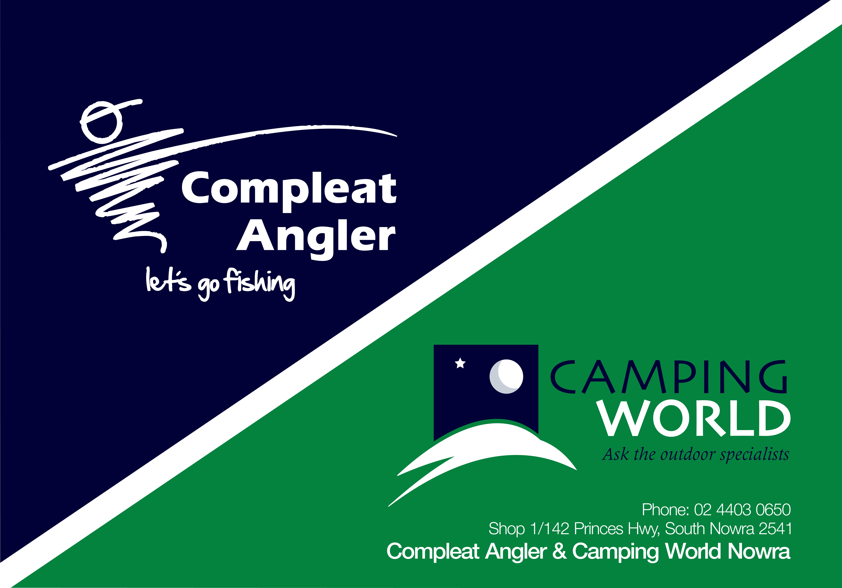

**Please return your completed entry form to:**

**Southern Bass Fishing Club:** [**southernbass2013@gmail.com**](mailto:southernbass2013@gmail.com)

**Payment via Direct Debit:**

**Southern Bass IMB Account**

**BSB 641-800 Account No 009137811**

***(Please include your name as a reference)***

**Venue: Bendeela Picnic Area, Kangaroo Valley**

**Accommodation & Amenities:** Accommodation is Camping only so bring your own tents and gear. Caravans and Campers are welcome. Bendeela is in a quiet part of Lake Yarrunga and the facilities are minimal. There are no Showers or Electricity but there are toilet blocks and drinking water.  
  
**Registration:** Upon arrival each participant will need to register for the competition at the administration tent from 3:00pm Friday 25th February onwards.

**Briefing:** Briefing will be on Friday 25th February 8:00 pm and will include the competition rules & regulations, fishing areas and details. Catch forms will be made available.

**New Rule: ALL FISH OVER 300mm will require PHOTO EVIDENCE ON SUPPLIED MEASURING BOARDS to be eligible for prizes (To be collected after briefing on Friday night)**

**Key Tags:** Numbered key tags will be issued to and must be handed in at the completion of each session. This will ensure that all competitors have returned.

Any person not handing in the key tag at the designated time will be penalised one centimetre per minute.

**Fishing Times:**

Saturday 26th February @ 5.30am to 5.00pm  
Sunday 27th February @ 5.30am to 11.00am

**All anglers must hold a current NSW Recreational Fishing Licence**

**and All Bass measured to fork length.**

**THIS WILL BE A SINGLE PERSON ENTRY EVENT NOT A TEAM EVENT**

**Safety:** Fishing is strictly by **PADDLE POWER ONLY**, No motors are permitted, either petrol or electric. The worthiness of craft being used is the responsibility of the competitor. Safety is of prime importance. Contestants fishing the Lake Yarrunga Bass Challenge do so at their own risk. Southern Bass Fishing Club Inc. will not accept any responsibility for accident, injury or loss occasioned during this event.

**Meals Provided by Southern Bass:**

**Friday Night:** Sausage sizzle prior to the briefing.

**Saturday Night**: **NO CATERING PROVIDED (BYO DINNER)**

**Sunday Lunch:** Sausage sizzle prior to the presentation 12pm.

Soft drinks will be available for a nominal fee by Southern Bass.

**The presentation will be held on Sunday at 12:30pm after the BBQ**

**Raffle:** A **REDUCED** raffle will take place on Saturday after dinner starting at approximately 7pm.

Tickets will be on sale from 12noon on the Saturday.

*All money raised from this and any Southern Bass event goes back into the water in the form of restocking and your entry fee will provide sponsorship for these bass.*

*Bass catch data collected from this event is part of NSW DPI on going bass catch monitoring.*

**Entries and Contacts**

**Entries will close on the 18th February. 2022. The event is limited to 100 ANGLERS. Save disappointment and return your entry early.**

**For more information contact**

Robert Halley: Mobile: 0417220924 Email: [halleyrj@bigpond.com](mailto:halleyrj@bigpond.com)

Linda Wright: Mobile: 0429540044 Email: [southernbass2013@gmail.com](mailto:southernbass2013@gmail.com)

Craig Hoare: Mobile: 0413641119

**Club COVID Matrix**

The Southern Bass Fishing Club has adopted the following principles regarding COVID -19 procedures:

* We will at all times comply with local, State and Federal COVID guidelines.

* We request that all members register their vaccination status with the Club Secretary ASAP

* We require that at any indoor club events all members be fully vaccinated.

* We request that all club outdoor events all members be fully vaccinated or, if not for any

reason, they so inform the club organiser. This shall not preclude such members from

participating in these events.

**LAKE YARRUNGA BASS CATCH 2022**

**Entry Application**

**Fishing Club:**

**Angler 1:**

**Surname: First Name:**

**Address: Phone:**

**Email address:**

**Angler 2:**

**Surname: First Name:**

**Address: Phone:**

**Email address:**

Senior Angler: x $30.00 = $ Junior Angler: x $15.00 = $   
  
I/We, the undersigned wish to participate in the Lake Yarrunga Bass Challenge and agree that I/we do so at our own risk. Worthiness of craft being used in this event is the responsibility of the competing angler and must meet NSW Maritime standards as safety is of prime importance. We agree to abide by the rules and regulations as set down by the committee of Southern Bass Fishing Club Inc. and agree that Southern Bass Fishing Club Inc. shall not be responsible or liable for any loss or damage to any person or property, personal injury or loss of life. We the undersigned have read and understand and abide by the entry conditions.

Signed Angler 1: Signed Angler 2:   
  
LIFE JACKETS MUST BE WORN BY ALL PARTICIPATING ANGLERS WHILST ON THE WATER

*Please make Cheques or Money orders payable to: Southern Bass Fishing Club. Post or email all entries to the* *treasurer.*

**THIS WILL BE A SINGLE PERSON ENTRY EVENT NOT A TEAM EVENT**

