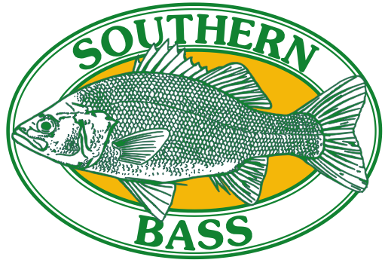

**Invite’s you to fish the**

**25th LAKE YARRUNGA CHALLENGE**

**10th - 12th NOVEMBER 2023**

**Entry Fee: Adult $100 Family $290 Junior $50 (under 16 years)**

**Early Bird: Adult $80 Family $200 Junior $40 (under 16 years)**

**Early Bird special must be paid by 1st October**

**Under 18yrs of age must be accompanied by Parent or Guardian**

**Entry fee allows for honorary membership for duration of bass challenge 6.30pm Friday till 2.00pm Sunday**

**LIFE JACKETS MUST BE WORN BY ALL PARTICIPATING ANGLERS WHILST ON THE WATER**

**This will be a TEAM EVENT**

**We would like to thank our PREMIUM SPONSORS**

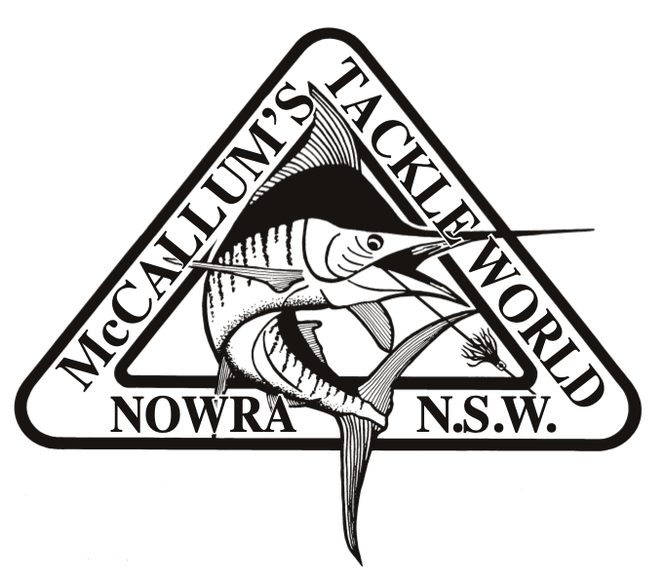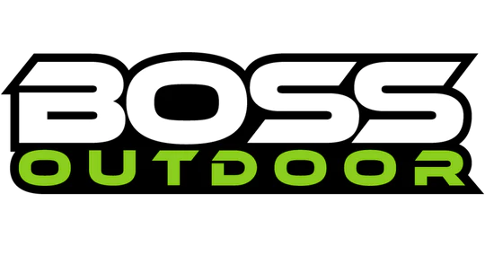

**::Sponsor Logo's:Frogley's Offshore.jpg**

**Venue: Bendeela Picnic Area, Kangaroo Valley**

**Accommodation & Amenities:** Accommodation is Camping only so bring your own tents and gear. Caravans and Campers are welcome. Bendeela is in a quiet part of Lake Yarrunga and the facilities are minimal. There are no Showers or Electricity but there are toilet blocks and drinking water.

**Registration:** Upon arrival each participant will need to register for the competition at the administration tent from 3:00pm Friday 10th November onwards.

**Briefing:** Briefing will be on Friday 10th November 8:00 pm and will include the competition rules & regulations, fishing areas and details. Catch forms will be made available.

**New Rule: ALL FISH CAUGHT OVER 300mm will require PHOTO EVIDENCE ON THE SUPPLIED MEASURING BOARDS to be eligible for compition trophies. (Measuring Boards can be collected after briefing on Friday night).**

**Key Tags:** Numbered key tags will be issued to and must be handed in at the completion of each session. This will ensure that all competitors have returned.

Any person not handing in the key tag at the designated time will be penalised one centimetre per minute.

**Fishing Times:** Saturday 10th November @ 5.30am to 5.00pm - Sunday 12th November @ 5.30am to 11.00am

**Fishing Access Point**: Bendeela Camping ground / (Tallowa Dam / below Hampton Bridge

**All anglers must hold a current NSW Recreational Fishing Licence.**

**All Bass measured to fork length.**

**Safety:** Fishing is strictly by **PADDLE/PEDAL POWER ONLY**, No motors are permitted, either petrol or electric. The worthiness of craft being used is the responsibility of the competitor. Safety is of prime importance. Contestants fishing the Lake Yarrunga Bass Challenge do so at their own risk. Southern Bass Fishing Club Inc. will not accept any responsibility for accident, injury or loss occasioned during this event.

**Meals Provided by Southern Bass:**

**Friday Night:** Sausage sizzle prior to the briefing.

**Saturday Night**: **CATERING PROVIDED**

**Sunday Lunch:** Sausage sizzle prior to the presentation 12pm.

Soft drinks will be available for a nominal fee by Southern Bass.

**Raffle:** A raffle will take place on Saturday starting at approximately 7pm.Tickets will be on sale from 12noon on the Saturday

**The presentation will be held on Sunday at 12:30pm after the BBQ**

*All money raised from this and any Southern Bass event goes back into the water in the form of restocking and your entry fee will provide sponsorship for these bass.*

*Bass catch data collected from this event is part of NSW DPI on going bass catch monitoring.*

**Entries will close on the 9th November 2023. The event is limited to 100 ANGLERS. Save disappointment and return your entry early.**

**Please return your completed entry form to:**

**Southern Bass Fishing Club:** [**southernbass2013@gmail.com**](mailto:southernbass2013@gmail.com)

**Payment via Direct Debit:**

**Southern Bass IMB Account: BSB 641-800 Account No: 009137811**

***(Please include your name as a reference)***

**For more information contact**

Robert Halley: Mobile: 0417220924 Email: [halleyrj@bigpond.com](mailto:halleyrj@bigpond.com)

Linda Wright: Mobile: 0429540044 Email: [southernbass2013@gmail.com](mailto:southernbass2013@gmail.com)

**LAKE YARRUNGA BASS CATCH 2023**

**Entry Application**

**Fishing Club:**

**Angler 1:**

**Surname: First Name:**

**Address: Phone:**

**Email address:**

**Angler 2:**

**Surname: First Name:**

**Address: Phone:**

**Email address:**

Senior Angler: = $ Junior Angler: = $   
  
I/We, the undersigned wish to participate in the Lake Yarrunga Bass Challenge and agree that I/we do so at our own risk. Worthiness of craft being used in this event is the responsibility of the competing angler and must meet NSW Maritime standards as safety is of prime importance. We agree to abide by the rules and regulations as set down by the committee of Southern Bass Fishing Club Inc. and agree that Southern Bass Fishing Club Inc. shall not be responsible or liable for any loss or damage to any person or property, personal injury or loss of life. We the undersigned have read and understand and abide by the entry conditions.

Signed Angler 1: Signed Angler 2:   
  
LIFE JACKETS MUST BE WORN BY ALL PARTICIPATING ANGLERS WHILST ON THE WATER

**Lake Yarrunga Bass Challenge Shirts (to be paid with entry fee)**

**Children sizes available on request**

|  |  |  |  |  |  |
| --- | --- | --- | --- | --- | --- |
| *Size* | *Fishing Shirt Long Sleeve* ***$55*** | *Hoddie/Jumper* ***$40*** | *Kids Polo Shirt* ***$30*** |  | ***Total Cost*** |
| *Small* |  |  |  |  |  |
| *Medium* |  |  |  |  |  |
| *Large* |  |  |  |  |  |
| *XL* |  |  |  |  |  |
| *2XL* |  |  |  |  |  |
| *3XL* |  |  |  |  |  |

Total amount of Entry Fee & Shirt payment = $____________________ Date Paid ___________________

**Payment via Direct Debit:**

**Southern Bass IMB Account**

**BSB 641-800 Account No 009137811**

***(Please include your name as a reference***

